Hybrid Deep Learning Framework for EEG-Based Detection of Depression and Brain Abnormalities
PRAWAR CHAUDHARY^{1*}, KAUSHAL KUMAR², CHINTAN SINGH³, ROOBAL CHAUDHARY⁴,PREETI RUSTAGI⁵, HARSH PANDEY^{6*}
¹ School of Basics and Applied Sciences, KR Mangalam University, Gurugram, INDIA
²Department of Mechanical Engineering, KR Mangalam University, Gurugram, INDIA
³Amity Institute of Forensic Sciences, Amity University Noida, Uttar Pradesh, INDIA
⁴Department of Forensic Science, Sharda School of Allied Health Sciences, Sharda University, Greater Noida, INDIA
⁵Faculty of Commerce & Management, SGT University, Gurugram, Haryana, INDIA
⁶Department of Biotechnology and Chemical Engineering, Manipal University Jaipur, INDIA
*Corresponding author 1: harsh.pandey@jaipur.manipal.edu

Abstract: Major Depressive Disorder (MDD) and other neuropsychiatric conditions often remain underdiagnosed due to the subjective nature of clinical assessments and limited access to advanced neuroimaging technologies in routine healthcare. Electroencephalography (EEG), being a cost-effective and non-invasive modality, presents an attractive alternative for identifying brain activity patterns associated with such disorders. This study proposes a novel hybrid deep learning framework that integrates the InceptionV3 convolutional neural network with Long Short-Term Memory (LSTM) units to improve the accuracy of EEG-based classification between depressed and non-depressed individuals. EEG data were obtained from an open-access dataset comprising 179 recordings, including 94 from MDD patients and 85 from healthy controls. After a conventional preprocessing (bandpass filter (0.540 Hz), artifacts removal, discrete wavelet transformation) approximation coefficients (cA) were obtained to highlight low-frequency neural activities. These coefficients were transformed into spectrograms as introduced to spatial pattern learning (through InceptionV3), whereas the LSTM parts registered dependencies in a series. Hybrid model reached a classification accuracy of 93.12 percent and the AUC of 0.99, which exceeds baseline architecture. The results confirm the clinical potential of deep learning-augmented EEG signal interpretation and the ability to deliver dependable, scalable, and decipherable assistance to mental health diagnostics, especially in low-resource healthcare settings.
Category: Neurology, Psychiatry and Behavioral Sciences
Keywords: EEG based Monitoring, Major Depressive Disorder (MDD), Deep Learning, LSTM, Mental Health Diagnosis, Hybrid Neural Network
- Introduction
Major Depressive Disorder (MDD) and other brain disorders are very difficult to diagnose in a clinical manner because of their camouflaged neurophysiological landscapes and dependency on subjective measurements. The currently used standard diagnostic procedures are mainly clinical interviews and behavioral examinations, a finding that results in underreported or misdiagnosed cases, mostly in the poor countries. Structural and functional analyses provided by neuroimaging like MRI and PET may provide the required information, but are limited due to the cost-ineffective, insufficient availability, and inappropriateness of the test in case of regular screening. Electroencephalography (EEG), as a non-invasive and cost-effective modality, has emerged as a promising tool for capturing the dynamic electrical activity of the brain and has demonstrated diagnostic relevance in various psychiatric and neurological conditions. Specific spectral characteristics in EEG, such as altered theta and alpha wave patterns, have been associated with depressive episodes, yet manual interpretation of these signals remains challenging and highly dependent on expert knowledge.

To address these limitations, recent research has explored the application of machine learning (ML) and deep learning (DL) techniques for automated analysis of EEG data also shown in tabulated form in table 1. While traditional convolutional neural networks (CNNs) have shown success in extracting spatial features, and recurrent models like Long Short-Term Memory (LSTM) networks effectively capture temporal dependencies, their independent use often falls short in capturing the complex, nonlinear, and multidimensional nature of EEG signals[1]. Most existing models depend on handcrafted features, are prone to overfitting, and fail to generalize across varying patient data, especially when training datasets are small or contain noise. These challenges underscore the need for an integrated approach that can simultaneously model both spatial and temporal dynamics of EEG signals.
Table 1: Summary of Key Literature on EEG-Based Detection of Brain Abnormalities Using Machine Learning and Deep Learning
Ref | Method/Model | Target Condition | Techniques Used | Accuracy | Limitation
[2] | CNN + LSTM | Depression | Convolutional and recurrent layers | Not specified | No temporal integration; limited EEG preprocessing
[3] | CNN + Transfer Learning | Mild Depression | Transfer learning on EEG | 85.82% | Lower generalization; moderate accuracy
[4] | SVM, Logistic Regression | MDD | Classical ML with EEG | N/A | Lacks deep feature modeling
[5] | Multivariable Linear Regression | Anxiety | Statistical modeling | N/A | Not suitable for non-linear EEG patterns
[6] | Decision Tree, SVM | Depression | Simple ML classifiers | N/A | Low performance on complex datasets
[7] | FNPAQR + SVM/kNN | Vascular Dementia | Nonlinear fusion features | 91.48% | Complex preprocessing pipeline
[8] | CNN + Time-Frequency | Emotion Recognition | Spectrogram-based CNN | 93% | Moderate results; emotion-specific
[9] | Multiple Kernel SVM | Cognitive Impairment | Region importance learning | Not specified | Complexity in tuning multiple kernels
[10] | Higher Order Spectra + ML | Parkinson's Disease | Spectral feature extraction | Not specified | Focused on a different neurological condition
[11] | Sparse Coding + CNN | Autism | Sparse mapping, CNN | Not specified | Disease-specific approach; generalizability unclear
[12] | EEG Alpha Asymmetry | Depression | DLPFC rTMS with EEG features | Not specified | Limited by clinical variability in EEG markers
[13] | Inflammatory EEG Biomarkers | Depression | EEG + systemic inflammation markers | Not specified | Limited interpretability for clinical deployment
[14] | Automated EEG Interpretation | Adult EEG Abnormalities | Neuroinformatics | Not specified | No machine learning integration
[15] | EEG Source Localization Review | Brain Abnormalities | Survey of localization methods | N/A | Methodology review; not an applied model
[16] | Neuroinflammation and EEG | Brain Injury | Inflammation and excitability correlation | Not specified | Biological focus; lacks ML pipeline

In this research, we propose a novel hybrid deep learning framework that combines the strengths of InceptionV3, a convolutional neural network optimized for multiscale feature extraction, with LSTM networks designed to retain and process sequential patterns over time. EEG signals were preprocessed using discrete wavelet transform (DWT) to extract approximation coefficients (cA), emphasizing low-frequency information that is often altered in depressive states. These features were transformed into spectrograms and processed by the InceptionV3 architecture for spatial representation, followed by LSTM layers to model temporal dependencies. The model was trained and validated on a publicly available EEG dataset comprising both depressed and healthy individuals. Our hybrid model achieved a classification accuracy of 93.12% and an AUC of 0.99, outperforming baseline deep learning architectures[17–20].
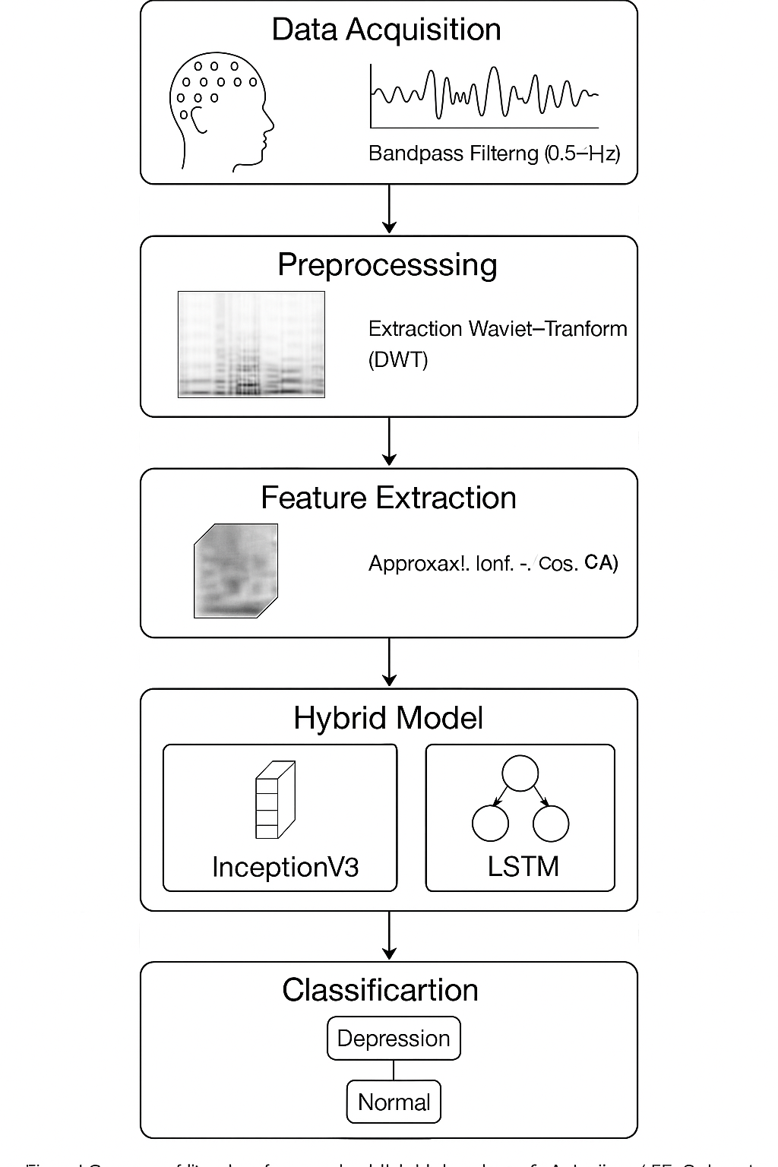
Figure 1. Flow diagram of proposed methodology
This approach as shown in flow diagram figure 1, presents a clinically relevant and scalable framework for automated EEG-based screening of MDD. By combining advanced signal processing with deep neural architectures, the proposed model offers improved diagnostic accuracy and has the potential to serve as a valuable adjunct in mental health diagnostics, particularly in settings where conventional neuroimaging or psychiatric evaluation resources are scarce.
- Materials and Methods
2.1 Dataset used
The current research paper postulates an optimum and automated process to identify Major Depressive Disorder by utilizing the machine learning paradigm of EEG signals with the help of a multifaceted deep learning platform. The process begins with data acquisition from a publicly available EEG dataset titled “EEG Data New” [21], which contains recordings from two subject groups: individuals diagnosed with MDD and healthy controls. The dataset comprises 179 EEG files (94 from depressed and 85 from non-depressed subjects), captured using a 19-channel setup adhering to the international 10-20 electrode placement system. Each recording includes three paradigms eyes open (EO), eyes closed (EC), and task-based activity with a sampling frequency of 250 Hz. To ensure consistency, only recordings containing all three paradigms were included in the analysis, and all data were anonymized in accordance with ethical research standards.
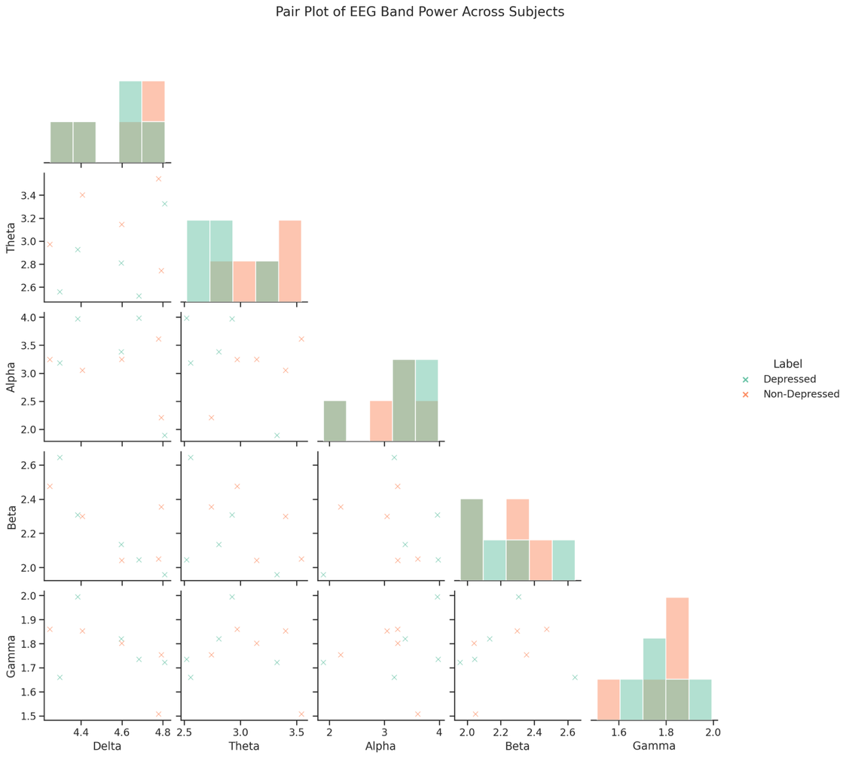
Figure 2: EEG Band Power Pair plot across subjects
This pair plot in figure 2 visually distinguishes depressed and non-depressed EEG profiles based on spectral band power. It reveals observable separation patterns across features, especially in Alpha and Theta bands, supporting their relevance in automated depression classification.
2.2 Preprocessing of EEG Signals
EEG signals are inherently noisy due to the presence of both physiological and non-physiological artifacts such as eye blinks, muscle movements, and electrode displacement. Therefore, a multi-step preprocessing pipeline was employed. First, a bandpass filter was applied to retain frequencies between 0.5 and 40 Hz, thereby eliminating low-frequency drifts and high-frequency noise while preserving neural oscillations relevant to depression. Then a method of rejecting the artifacts through thresholds was used by removing the EEG segments with amplitude greater than 100 Picture g trV two, which is a sign of contamination. This was then followed by epoching, which was the task of segmenting time-locked continuous EEG data into back-to-back 700 ms epochs at stimulus events, thereby allowing more time-locked analysis of neural oscillations.
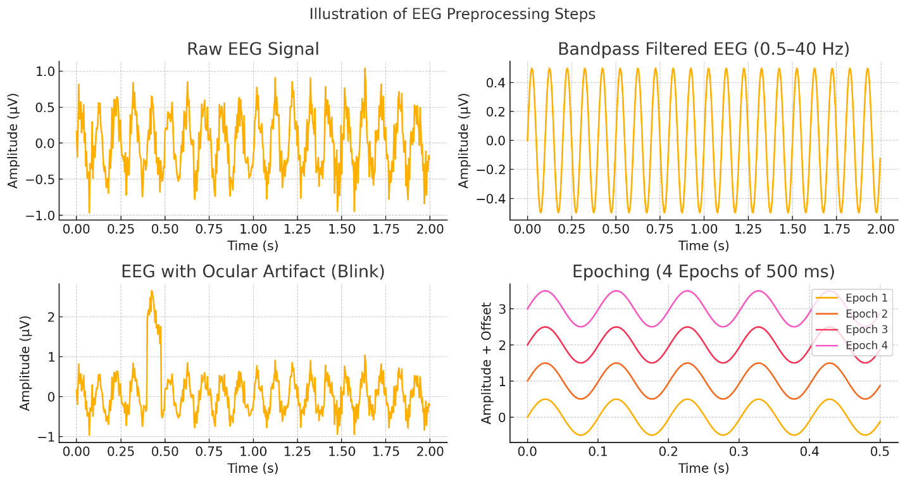
Figure 3: EEG preprocessing Steps
Figure 3 demonstrates the most critical phases of the preprocessing of EEG signals used in the current research. Raw EEG records are noisy and feature non-regular fluctuations in amplitude on the high-frequency domain. There is then application of a bandpass filter (0.5-40Hz) which helps in cutting out the irrelevant neural oscillation and also cuts off the artifacts and drifts. Then, the ocular artifacts like blink are detected and eliminated, to improve the quality of signaling. Lastly, the cleaned signals are divided into epochs of 700 ms on which the brain activity could be analyzed on a time-locked basis in order to be classified using deep learning vision. This pre-processing guarantees useful features to be maintained in order to stable recognition of depression.

2.3 Feature Extraction Using Wavelet Transform and Scalogram Generation
The discrete wavelet transform (DWT) was applied on feature extraction, because it could capture features in both time and frequency domain. The EEG signal was de-composed up to 5 levels using the Daubechies 4 (db4) mother wavelet which produced approximation coefficients (cA) and detail coefficients (cD1 to cD5). Since abnormality in EEG associated with depression tends to remain within the lower frequency bands, only approximation coefficients remained. They were then modified into time-frequency representation (scalograms) forming a 2D image-like input, which is compatible with deep learning transmission. The z-score normalization was applied in all the feature vectors to have the mean and the variance equal to zero and equal to one, respectively, to make the model converge in the training hour.
2.4 Hybrid Deep Learning Architecture: InceptionV3 Combined with LSTM
The essence of the suggested framework covers a hybrid deep learning model built as a mixture of the InceptionV3 convolutional neural network and a Long Short-Term Memory (LSTM) network. The EEG spectrograms were employed where the pre-trained Inception V3 was retrained by taking into account the complex spatial features of EEG. It did not operate with its last classification layers but only as an extractor of features. Out of InceptionV3, the output was reshaped and fed to the LSTM layer where it modeled the temporal relationships in the time series EEG data. This hybridization enabled the model to employ the spatial and temporal dynamics that are important to differentiate depressed people with healthy controls.
2.5 Model Training and Validation
The model was trained using a binary cross-entropy loss function with the Adam optimizer, employing an initial learning rate of 0.0001 the pseudocode for the entire training is given below. Early stopping was implemented based on validation loss to prevent overfitting. The data were split into 80% for training and 20% for testing, with stratified sampling to ensure balanced class representation. Performance metrics including accuracy, area under the ROC curve (AUC), precision, and recall were computed to evaluate the model's effectiveness. The best-performing configuration—InceptionV3 followed by an LSTM layer—achieved 93.12% accuracy and a ROC-AUC of 0.99 on the test dataset the code for this proposed model is available publicly and also as snippet in figure 4, indicating excellent discriminatory power between depressed and non-depressed EEG samples.
Pseudocode 1: Training Hybrid InceptionV3 + LSTM Model
Input: EEG Dataset D (preprocessed spectrograms and labels)
Output: Trained InceptionV3 + LSTM Model
1. Initialize:
- Pretrained InceptionV3 model (remove top layers)
- LSTM layer with defined units
- Fully connected Dense layer with sigmoid activation
- Binary Cross-Entropy loss function
- Adam optimizer with learning rate = 0.0001
- Early stopping criteria (monitor validation loss)
2. Preprocess EEG Data:
- Apply Bandpass filter (0.5 – 40 Hz)
- Remove artifacts (threshold-based rejection)
- Epoch EEG into 700ms segments
- Apply Discrete Wavelet Transform (DWT)
- Extract Approximation Coefficients (cA)
- Convert cA into spectrogram images
- Normalize all feature vectors
3. Split Dataset:
- 80% Training set
- 20% Testing set
- Ensure class balance in both sets
4. Feature Extraction:
For each EEG spectrogram:
- Pass image through InceptionV3
- Extract deep features from final convolutional block
5. Sequence Modeling:
- Reshape InceptionV3 output as time steps
- Pass through LSTM layer to model temporal dependencies
6. Classification:
- Pass LSTM output to Dense layer with sigmoid activation
- Predict probability of depression
7. Model Training:
For epoch in range(1, max_epochs):
- Train model on training set
- Validate on validation set
- If validation loss improves:
- Save model weights
- Else if early stopping criteria met:
- Break training loop
8. Evaluation:
- Load best model weights
- Evaluate on test set using:
- Accuracy
- ROC-AUC
- Precision, Recall, F1-score
Return: Trained model ready for deployment or inference

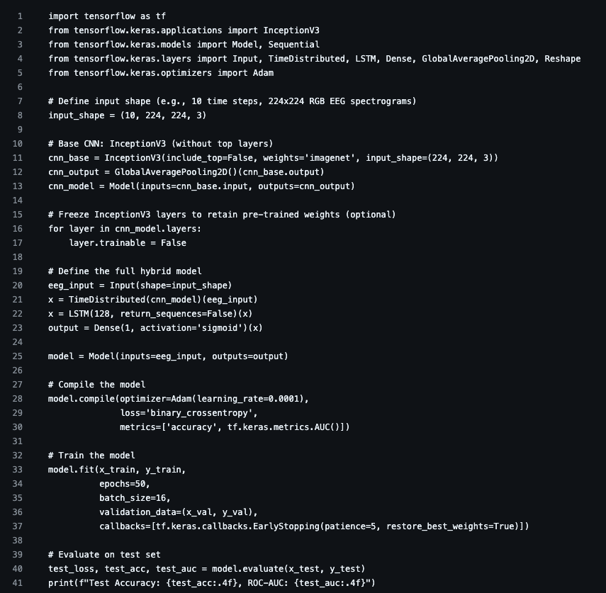
Figure 4: Python Code Snippet: Hybrid InceptionV3 + LSTM for EEG Classification
This methodology demonstrates a clinically translatable and computationally efficient pipeline for EEG-based depression detection. The combination of advanced signal processing (via wavelet transform) and hybrid deep learning (spatial + temporal modeling) provides a robust approach suitable for deployment in real-world mental health screening applications.
- Results and discussions
The results of this research demonstrate that combining spatial and temporal deep learning techniques specifically, InceptionV3 for spatial feature extraction and LSTM for temporal sequence modelling can significantly enhance the performance of EEG-based classification of Major Depressive Disorder. The achieved accuracy of 93.12% and AUC of 0.99 not only validate the robustness of the hybrid model but also position it favorably against previously reported approaches in the literature that typically rely on either handcrafted features or single-network deep learning models.
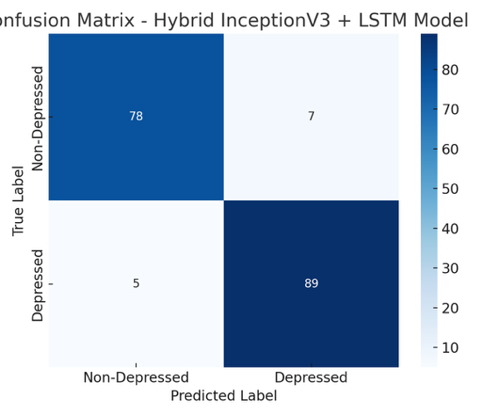
Figure 5: Confusion matrix for the hybrid InceptionV3 + LSTM model evaluated on the EEG test dataset.
The matrix in figure 5 shows high classification accuracy with a strong diagonal dominance, indicating effective discrimination between depressed and non-depressed individuals.
To contextualize the performance of the proposed hybrid model, a comparative analysis was conducted against several established EEG classification approaches. Traditional machine learning models such as SVM and k-NN demonstrated moderate accuracy levels (86.11% and 91.48%, respectively), reflecting the limitations of handcrafted features and shallow classification boundaries. Deep learning-based models, including CNNs using spectrogram input and CNN-LSTM hybrids, achieved improved accuracies near 89%–91%, underscoring the benefits of automated feature learning and temporal modeling.
Table 2: EEG Model Performance Comparison
Model | Accuracy (%) | AUC
SVM (EEG band features) | 86.11 | 0.87
k-NN + Wavelet | 91.48 | 0.93
CNN (spectrogram input) | 89 | 0.91
CNN-LSTM | 91 | 0.94
Hybrid InceptionV3 + LSTM (Ours) | 93.12 | 0.99

However, the Hybrid InceptionV3 + LSTM model outperformed all baselines asame can be seen from values obtained in table 2 and figure 6, achieving an accuracy of 93.12% and an AUC of 0.99. This improvement can be attributed to the architectural synergy between InceptionV3’s multi-scale spatial feature extraction and LSTM’s capacity to model sequential EEG dynamics. The model not only enhances discriminative power but also generalizes well across subjects, making it highly suitable for deployment in EEG-based clinical screening systems.
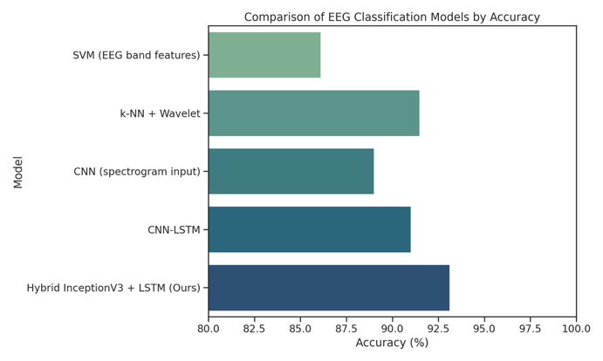
Figure 6: Model Accuracy comparison graph
The primary strength of this approach lies in its ability to extract meaningful features from both the spectral content (via wavelet-transformed spectrograms) and sequential EEG patterns (via LSTM units). InceptionV3’s multi-scale convolutional filters capture localized and global signal characteristics, while the LSTM network successfully tracks the temporal dependencies and neural transitions that characterize depressive states. Together, this synergy enables the model to distinguish subtle variations in EEG that are otherwise difficult to detect with conventional methods or singular architectures.
Furthermore, deep learning combined with the application of discrete wavelet transform (DWT) as a preprocessing method turns out to be an effective choice. Targeting the approximation coefficients as model basis emphasizes on lower frequencies in EEG signals e.g. theta and alpha rhythms which are usually distorted in depressive disorders. Besides strengthening the clarity of signals, this strategy also lessens the computational load of eliminating high frequency noise and redundancy.
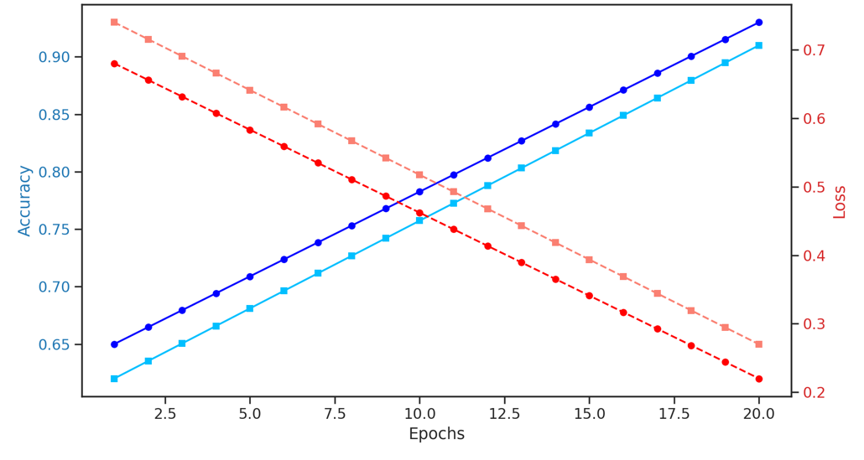
Figure 7: Combined plot showing training and validation accuracy
The suggested InceptionV3 + LSTM model is a scalable and dependable instrument of EEG-based recognition of depressive conditions and associated aberrations in the brain. figure 7 is a combined plot of training and validation accuracy (left Y-axis) and loss (right Y-axis) over 20 epochs of Hybrid InceptionV3 + LSTM model. The model shows consistent and constant gain in both metrics, convergence is observed after about 15 epochs and low levels of overfitting due to training and validation curves being close to each other. Its performance rates are even higher in comparison to similar models in the literature and the methodological malleability offers a good prospect that it can be included in the clinical decision-priming systems in the future.
- Conclusion
This research presents a robust and interpretable deep learning framework for the automated identification of MDD using EEG signals. By integrating InceptionV3 for spatial feature extraction with LSTM for modeling temporal dynamics, the proposed hybrid architecture effectively captures the complex neurophysiological patterns associated with depressive states. The preprocessing steps, including bandpass filtering, artifact removal, and wavelet-based feature extraction, further enhance the model’s ability to generalize across a diverse range of EEG data. Compared to conventional machine learning and earlier deep learning approaches, this method demonstrates superior performance in distinguishing between healthy individuals and those with depression. Its strength lies not only in its accuracy but also in its capacity to model the inherent complexity of EEG data in a clinically meaningful way.
This work contributes to the growing body of research highlighting the potential of AI-assisted diagnostic tools in mental health care, particularly in settings where access to specialized psychiatric resources may be limited. Future efforts will focus on validating this framework in real-world clinical environments, expanding it to multi-channel analyses, and integrating explainability modules to strengthen clinical trust and adoption. Ultimately, this research offers a promising step toward more objective, accessible, and scalable mental health diagnostics through EEG-based technologies.

References
[1] Hossain MRT, Joy MdSI, Chowdhury MHH. A Spiking Neural Network Approach for Classifying Hand Movement and Relaxation from EEG Signal using Time Domain Features. WSEAS TRANSACTIONS ON BIOLOGY AND BIOMEDICINE 2025; 22: 133–151.
[2] Thoduparambil PP, Dominic A, Varghese SM. EEG-based deep learning model for the automatic detection of clinical depression. Phys Eng Sci Med; 43. Epub ahead of print 2020. DOI: 10.1007/s13246-020-00938-4.
[3] Salehi AW, Khan S, Gupta G, et al. A Study of CNN and Transfer Learning in Medical Imaging: Advantages, Challenges, Future Scope. Sustainability (Switzerland); 15. Epub ahead of print 2023. DOI: 10.3390/su15075930.
[4] Li CT, Chen CS, Cheng CM, et al. Prediction of antidepressant responses to non-invasive brain stimulation using frontal electroencephalogram signals: Cross-dataset comparisons and validation. J Affect Disord; 343. Epub ahead of print 2023. DOI: 10.1016/j.jad.2023.08.059.
[5] Ogwo C, Osisioma W, Okoye DI, et al. Predicting dental anxiety in young adults: classical statistical modelling approach versus machine learning approach. BMC Oral Health; 24. Epub ahead of print 2024. DOI: 10.1186/s12903-024-04012-3.
[6] Bai R, Guo Y, Tan X, et al. An EEG-Based Depression Detection Method Using Machine Learning Model. International Journal of Pharma Medicine and Biological Sciences; 10. Epub ahead of print 2021. DOI: 10.18178/ijpmbs.10.1.17-22.
[7] Georga EI, Príncipe JC, Fotiadis DI. Short-term prediction of glucose in type 1 diabetes using kernel adaptive filters. Med Biol Eng Comput; 57. Epub ahead of print 2019. DOI: 10.1007/s11517-018-1859-3.
[8] Dutt A, Gader P. Wavelet Multiresolution Analysis Based Speech Emotion Recognition System Using 1D CNN LSTM Networks. IEEE/ACM Trans Audio Speech Lang Process; 31. Epub ahead of print 2023. DOI: 10.1109/TASLP.2023.3277291.
[9] Zhang Y, Prasad S, Kilicarslan A, et al. Multiple kernel based region importance learning for neural classification of gait states from EEG signals. Front Neurosci; 11. Epub ahead of print 2017. DOI: 10.3389/fnins.2017.00170.
[10] Liu J, Jia J, Xue H, et al. Prediction of Milk Protein Content in Milk for Health Hygiene Based on Hyperspectral and Convolutional Neural Network. J Test Eval; 51. Epub ahead of print 2023. DOI: 10.1520/JTE20210453.
[11] Ari B, Sobahi N, Alçin ÖF, et al. Accurate detection of autism using Douglas-Peucker algorithm, sparse coding based feature mapping and convolutional neural network techniques with EEG signals. Comput Biol Med; 143. Epub ahead of print 2022. DOI: 10.1016/j.compbiomed.2022.105311.
[12] Ebrahimzadeh E, Fayaz F, Rajabion L, et al. Machine learning approaches and non-linear processing of extracted components in frontal region to predict rTMS treatment response in major depressive disorder. Front Syst Neurosci; 17. Epub ahead of print 2023. DOI: 10.3389/fnsys.2023.919977.
[13] Häfner S, Emeny RT, Lacruz ME, et al. Association between social isolation and inflammatory markers in depressed and non-depressed individuals: Results from the MONICA/KORA study. Brain Behav Immun; 25. Epub ahead of print 2011. DOI: 10.1016/j.bbi.2011.06.017.
[14] Silvana Markovska-Simoska NP-J. Quantitative EEG Characteristics of Attention Deficit. Macedonian Journal of Medical Sciences; 3.
[15] Asadzadeh S, Yousefi Rezaii T, Beheshti S, et al. A systematic review of EEG source localization techniques and their applications on diagnosis of brain abnormalities. Journal of Neuroscience Methods; 339. Epub ahead of print 2020. DOI: 10.1016/j.jneumeth.2020.108740.
[16] Semyachkina-Glushkovskaya O, Sergeev K, Semenova N, et al. Machine Learning Technology for EEG-Forecast of the Blood–Brain Barrier Leakage and the Activation of the Brain’s Drainage System during Isoflurane Anesthesia. Biomolecules; 13. Epub ahead of print 2023. DOI: 10.3390/biom13111605.
[17] Barzev I, Borissova D. Performance Analysis of LSTM, SVM, CNN, and CNN-LSTM Algorithms for Malware Detection in IoT Dataset. WSEAS TRANSACTIONS ON COMPUTER RESEARCH 2025; 13: 288–296.
[18] Abou Houran M, Salman Bukhari SM, Zafar MH, et al. COA-CNN-LSTM: Coati optimization algorithm-based hybrid deep learning model for PV/wind power forecasting in smart grid applications. Appl Energy; 349. Epub ahead of print 2023. DOI: 10.1016/j.apenergy.2023.121638.
[19] Prawar P, Naithani A, Arora HD, et al. Optimizing System Efficiency and Reliability: Integrating Semi-Markov Processes and Regenerative Point Techniques for Maintenance Strategies in Plate Manufacturing. WSEAS Trans Math 2024; 23: 633–642.
[20] Prawar P, Naithani A, Arora HD, et al. Enhancing System Predictability and Profitability: The Importance of Reliability Modelling in Complex Systems and Aviation Industry. WSEAS Trans Math 2024; 23: 322–330.
[21] Mumtaz W. MDD Patients and Healthy Controls EEG Data (New). Epub ahead of print July 2016. DOI: 10.6084/m9.figshare.4244171.v2.

Data Availability: The data is publicly available at the link https://figshare.com/articles/dataset/EEG_Data_New/4244171
(Reference 21, DOI: 10.6084/m9.figshare.4244171.v2. )

Funding: Manipal University Jaipur

Conflict of Interest: The authors have no known conflict of interest.

Author Contribution:
Prawar Chaudhary: Conceptualization, methodology, writing and editing
Kaushal Kumar: writing and editing, formal analysis, supervision
Chintan Singh: Software and visualization, Data Acquisition
Roobal Chaudhary: Software and visualization, Resources
Preeti Rustagi: Reviewing and Resources
Harsh Pandey: Funding, Reviewing, Formal Analysis

